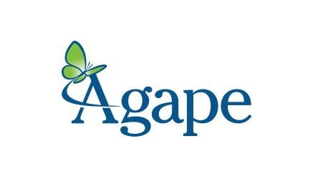
Our 2017 Sponsors

Platinum Level

Majestic Realty Co

Equifax

Gold Level

Sarah & Jim Kennedy

Paul & Carol Garcia

Silver Level

Nancy & Micheal Koziol

West Paces Advisors

Susan & Jeffrey Cimbalo

Shayla Rumely

Bonnie & Jay Harris

Elizabeth & Michael Klump

Hennessy Automobile Companies

Marie & Brad Foster

Bronze Level

Susan & Dean Morris

Sally & Jim Hinkle

Lisa & Joe Bankoff

Amie & Fred Herbert

Deanna & Mark Harris

Stuart & Chip Watson

Janet & George H. Johnson

Magner & Porter Lummus

Virginia S. Williams

Margot & Robert Shuford

Carol & Charles Doty

Esther & Jim Stokes

Brian & Lee Williams

Donna Hyland

Wesley Huffard

Supporting Level

Ruthanna & Bill Bost

Denise & Jay D. Mitchell

John & Peggy Shepard

Lesley & Jamie Carroll

Kaki & Mike Behr

Elsie & Jim Henderson

Brenda & Charles Moseley

Nicole & Russ Allen

Laurie & Chad Hood

Karen & Haynes Taylor

Cam & John Fenton

Elinor & Tom Jones

Caroline & Spence McClelland

Judy & Dick Allison

Jenny Allen

Lucy & John Westney

Jane & Derek Hardesty

Sally & Allen McDaniel

Robin & Stockton Croft

Catherine & Blake Young

Clair & Thos Miller

Lacey & Bill Jordan

Beth Park

Sally & Bill Montgomery

