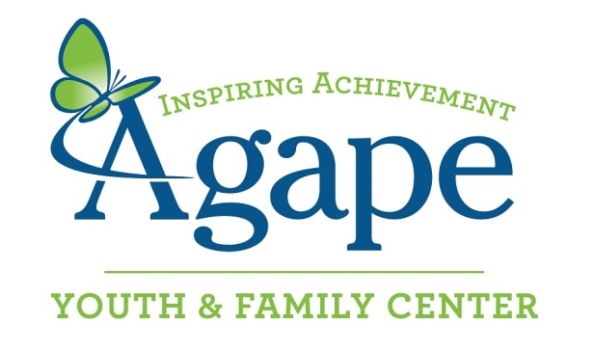

Nutritious Meal Pick Up Menu- Fall 2017

Thank you for partnering with Agape to provide nutritious meals for our children. Agape serves a community which includes more than 2,000 school-age children from underserved families in Atlanta. Agape is at capacity, with 200 school-age children enrolled, providing academic support and family services which focus on character development, academic achievement, reading proficiency by third grade, high school graduation and post-graduation placement. High school seniors enrolled at Agape have a 100% graduation rate. After graduation, 20% find employment, 40% vocational school and 40% go to college.

Choosing your Date(s)
If you have received an invite from Sign Up Genius, please use the simple selection process.

If you have NOT received an invite, please email Marlon Montgomery at mmontgomery@agapeatlanta.org or call (678) 428-5704 to receive one.

Delivery Locations
The E. Rivers Elementary School program and Ragtime are located at:

Agape Youth & Family Center
2353 Bolton Road, First Flooor, Atlanta, GA 30318
Arrival Contact is Alan Maxcy (amaxcy@agapeatlanta.org), mobile 404-697-5582 for E. Rivers
Arrival Contact is Tiffany Lloyd (tlloyd@agapeatlanta.org), office 404-367-3942 for Ragtime

The Bolton Academy Elementary School program and Sutton Middle School Program are at:

Trinity Presbyterian Church, Building D, Second Floor
3003 Howell Mill Road, Atlanta, GA 30318
Arrival Contact is Marlon Montgomery, mobile 678-428-5704 for Bolton & Sutton

Place your order at one of the following stores at least 24 hours before your scheduled visit. Stop by the store and pick up your order on the way to the program. Prices below are subject to change, and do not include tax.
If you would like to purchase from a different store or cook for the Agape children yourself, please be prepared to serve 54 students for E. Rivers Elementary, 63 students for Bolton Academy, or 40 students for Sutton Middle.
Publix Super Market Publix Super Market Publix Super Market

Howell Mill Village West Paces Ferry Moores Mill Center

2020 Howell Mill Rd NW 1250 W. Paces Ferry Rd NW 2275 Marietta Blvd. NW

Atlanta, GA 30318 Atlanta, GA 30327 Atlanta, GA 30318
(404) 609-7840 (404) 848-1610 (404) 351-4794

E. Rivers Elementary School Students at Agape Youth & Family Center at 4:30pm

- Publix Deli Sub Sandwich Option:
1 Large Sub Platter (9 subs cut 4x): $60
1 Medium Sub Platter (6 subs cut 4x): $37
2- Medium size fresh fruit trays $66
5 – 10.5oz bags of potato chips or pretzels: $20_
$183

- Chicken Tender Option:
1 Large Chicken Tender Platter $50
1 Medium Chicken Tender Platter $40
2 Medium Fresh Fruit Trays $66
2 Medium Fresh Vegetable Platters $60
$216

Bolton Academy Elementary School Students at Trinity Presbyterian Church btwn 4:15 and 4:30pm

- Publix Deli Sub Sandwich Option:
3 Medium Sub Platter (6 subs cut 4x): $111
1 Small Sub Platter (4 subs cut 4x): $27
2- Medium size fresh fruit trays $66
5 – 10.5oz bags of potato chips or pretzels: $20_
$224

- Chicken Tender Option:
3 Large Chicken Tender Platters $150
2 Medium Fresh Fruit Trays $66
2 Medium Fresh Vegetable Platters $60
$276

Sutton Middle School Students at Trinity Presbyterian at 5:30pm
- Publix Deli Sub Sandwich Option:
2 Medium Sub Platter (6 subs cut 4x): $74
1 Small Sub Platter (4 subs cut 4x): $27
2- Medium size fresh fruit trays $66
4 – 10.5oz bags of potato chips or pretzels: $16_
$183

- Chicken Tender Option
2 Medium Chicken Tender Platters $80
2 Medium Fresh Fruit Trays $66
2 Medium Fresh Vegetable Platters $60
$206

The Ragtime Senior Citizens at Agape Youth & Family Center at 11:00am
- Sub Sandwich Option:
2 Medium Sub Platters (6 subs cut 4x): $74
2 – 10.5oz bags of potato chips: $10
1 –Large party size fresh fruit tray $45
$129

OR

Chipotle
2020 Howell Mill Road, NW #39
Atlanta, GA 30318
1-800-244-7685

Bolton Academy Elementary School Students at Trinity Presbyterian Church at 4:15pm
- Chipotle Burrito Box (35 large burritos *ask to cut them all in half)
Burrito includes choice of:
- Choice of two meats, black beans, rice, salsa and cheese
- Burrito box should also include enough chips and salsa
______ ___________
$331.51 (price including tax when ordering for a nonprofit organization)

E. Rivers Elementary School Students at Agape Youth & Family Center at 4:30pm
- Chipotle Burrito Box (30 large burritos *ask to cut them all in half)
Burrito includes choice of:
- Choice of two meats, black beans, rice, salsa and cheese
- Burrito box should also include enough chips and salsa
______ ___________
$285.86 (price including tax when ordering for a nonprofit organization)

Sutton Middle School Students at Trinity Presbyterian at 5:30pm OR
The Ragtime Seniors at Agape Youth & Family Center at 11:00am
(Each group requires the same sized order)
- Chipotle Burrito Box (25 large burritos *ask to cut them all in half)
Burrito includes choice of:
- Choice of two meats, black beans, rice, salsa and cheese
- Burrito box should also include enough chips and salsa
______ ___________
$228.69 (price including tax when ordering for a nonprofit organization)

OR

Kroger
1715 Howell Mill Road NW
Atlanta, GA 30318
(404) 355-7886

Bolton Academy Elementary School Students at Trinity Presbyterian Church at 4:15pm OR
E. Rivers Elementary School Students at Agape Youth & Family Center at 4:30pm OR
Sutton Middle School Students at Trinity Presbyterian at 5:30pm OR
The Ragtime Seniors at Agape Youth & Family Center at 11:00am
(All groups require the same order)

- Baked Chicken Option:
  - 1- 96 piece baked chicken tray $90
  - (*For Sutton Middle and Ragtime Seniors, ask for half the order of chicken, 48 pieces)
  - 2 Fresh Fruit Platters $60
  - 2 Fresh Vegetable Platters $54
___________________________________
$204

For more information about Agape please go to www.agapeatlanta.org

